

 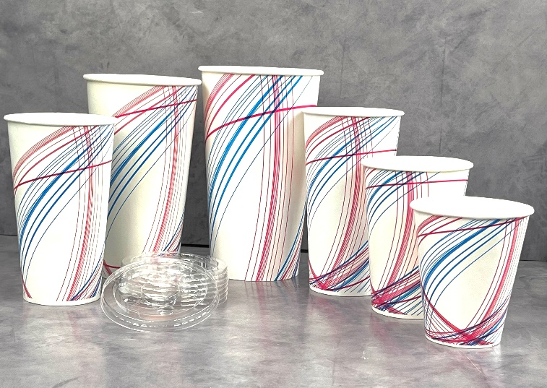 

|  |  |  |  |  |  |  |  |
| --- | --- | --- | --- | --- | --- | --- | --- |
| **COLD CUPS** | |  |  |  |  |  |  |
|  |  |  |  |  |  |  |  |
| **Item Number** | **Description** | **Case Count** | **Inner Pack** | **Case Cube** | **Case Weight** | **Tie x High** | **Pallet Count** |
| C12 | Bella | 2000 | 20/100 | 3.9 | 36 | 9 x 4 | 36 |
| C16 | Bella | 1000 | 20/50 | 2.7 | 24 | 9 x 5 | 45 |
| C20 | Bella | 1000 | 20/50 | 3.49 | 28 | 9 x 4 | 36 |
| C22 | Bella | 1000 | 20/50 | 3.71 | 29 | 9 x 4 | 36 |
| C32 | Bella | 500 | 20/25 | 3.72 | 23 | 6 x 5 | 30 |
| C44 | Bella | 500 | 20/25 | 4.91 | 33 | 6 x 5 | 30 |
|  |  |  |  |  |  |  |  |
|  |  | SYMBOL PET 1 Logo PNG Vector (EPS) Free Download   |  | | --- | |  | |  |  |  |  |  |
| **COLD CUP LIDS** | | | |  |  |  |  |
|  |  |  |  |  |  |  |  |
| **Item Number** | **Description** | **Case Count** | **Inner Pack** | **Case Cube** | **Case Weight** | **Tie x High** | **Pallet Count** |
| L1222 | 12-22oz Flat | 1000 | 10/100 | 1.42 | 5 | 6 x 12 | 72 |
| L32 | 32oz Flat | 1000 | 10/100 | 2.36 | 7 | 4 x 10 | 40 |
| L44 | 44oz Flat | 1000 | 10/100 | 2.71 | 8 | 4 x 10 | 40 |
| DL1222 | 12-22oz Dome | 1000 | 10/100 | 1.58 | 8 | 6 x 12 | 72 |
| DL44 | 44oz Dome | 1000 | 10/100 | 3.06 | 13 | 4 x 9 | 36 |

**Continental Cup Company | 1920 Spillman Drive | Bethlehem PA 18015**

[**www.continentalcup.com**](http://www.continentalcup.com)

**info@continentalcup.com**